Lec 3 Design Landing Part1

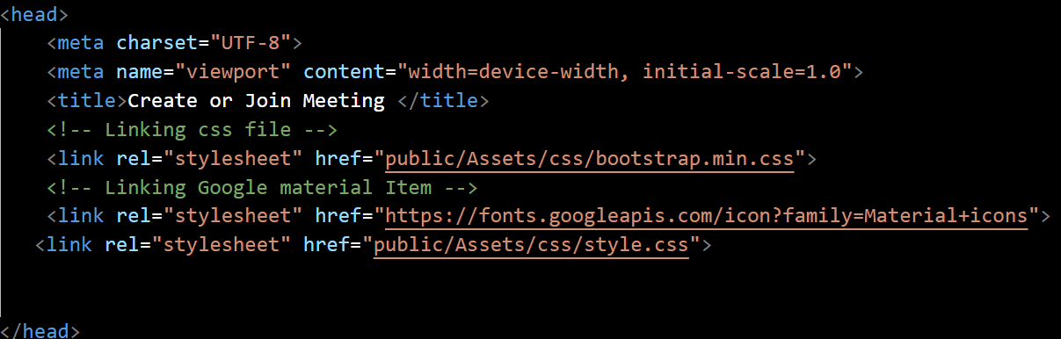

* 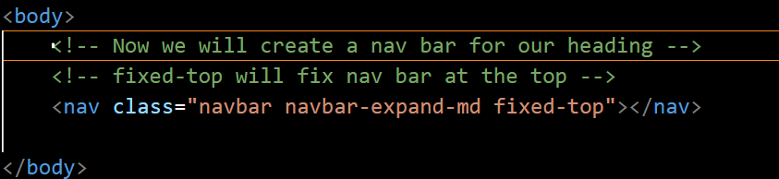
* Explaination:
* **<nav>**: This is the HTML element used to define a navigation section.
* **class="navbar navbar-expand-md fixed-top"**: These are the CSS classes applied to the **<nav>** element, defining the styling and behavior of the navigation bar.
  + **navbar**: This class is the base class for the navigation bar component in Bootstrap.
  + **navbar-expand-md**: This class specifies that the navigation bar should expand to occupy the full width of the screen on medium-sized devices and larger.
  + **fixed-top**: This class makes the navigation bar fixed to the top of the viewport, so it remains visible even when scrolling.
* 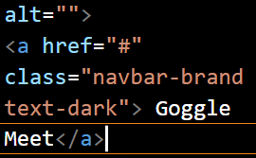

**class="navbar-brand text-dark"**: These are the CSS classes applied to the anchor element.

* **navbar-brand**: This class is used in Bootstrap to style the brand/logo section of the navigation bar.
* **text-dark**: This class sets the text color to dark. By default, Bootstrap applies a light text color to the navbar brand.
* 
* The "navbar-collapse" class is used to indicate that the content should collapse when the viewport width decreases, such as on smaller screens or when a hamburger menu is activated.
* 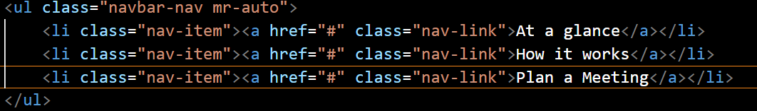
* Now on right side we will one nav-link for sign in and two buttons
* 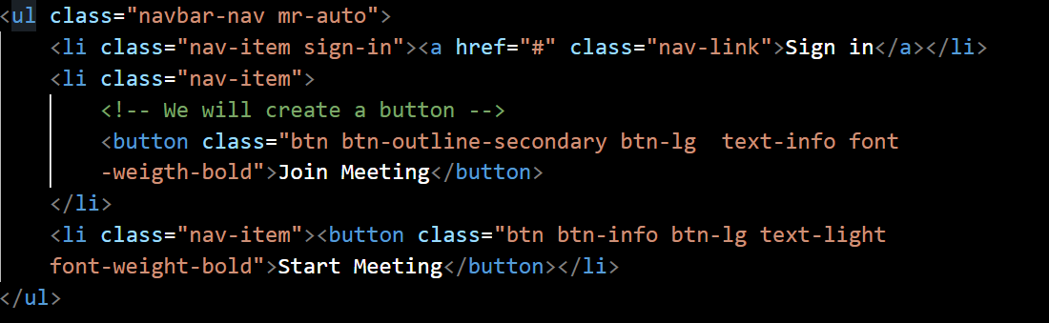
* Now we will apply styling
* 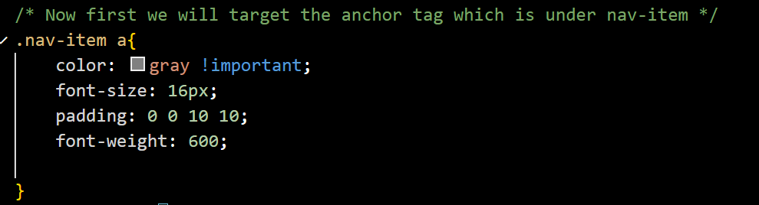
* Now we will make a custom class in css which we will apply to html file
* 